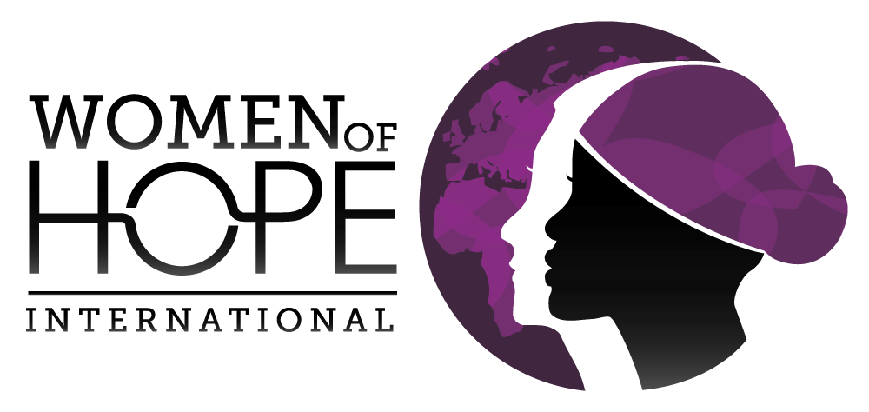
DONOR BILL OF RIGHTS
TRANSFORMATIONAL GIVING occurs in response to the faithfulness of God, when like-minded ministry partners enter into relationship with humility, exercising wise stewardship and seeking to fulfill God’s purposes. In order to help foster and protect healthy and thriving relationships with our donors, to promote transparency and integrity in all aspects of the organization and to ensure the trust of prospective and current Women of Hope International (WOHInt) supporters, we declare that all ministry partners (donors) have these rights:
I
To be informed of WOHInt’s mission, the way the organization intends to use donated resources, and its capacity to use contributions effectively for their intended purposes
II
To be informed of the identity of those serving on the WOHInt Board of Directors, and to expect the Board to exercise prudent judgment in its stewardship responsibilities
III
To have access to WOHInt’s most recent financial statements
IV
To be assured their contributions will be used for the purposes for which they were given
V
To receive appropriate acknowledgement and recognition for their contributions
VI
To be assured that information about their contribution is handled with respect and confidentiality to the extent provided by law
VII
To expect that all relationships with individuals representing organizations of interest to the ministry partner will be professional in nature
VIII
To be informed whether those seeking contributions are volunteers, employees of WOHInt or hired solicitors
IX
To have the opportunity for their names to be deleted from mailing lists that WOHInt may intend to share
X
To have the freedom to ask questions when making a contribution and to receive prompt, truthful and forthright answers

